Title: Smart Budget Planner – Python Web Application

  - By:
Student Name: Salet Varghese
Register Number: 15462
Class: S6 CSE C
Course: Python Programming Mini Project
Submission Date: 11/03/26

Contents

Contents | Page Number
Abstract | 3
Problem Description | 4
Libraries & Tools Used | 5
System Design / Workflow | 6
Implementation Details | 7
Results & Output | 8
Conclusion & Scope for Mini Project Extension | 10
References | 11

Abstract
Budget planning is an important activity that helps individuals manage their income and expenses effectively. Many people struggle to track where their money is spent and how much they save. The Smart Budget Planner is a web-based application developed using Python that helps users plan and analyze their budget easily. The system allows users to enter their income and different expense categories, then calculates the total expenses and remaining balance. It also provides graphical visualization of expenses using a pie chart and offers smart insights based on spending patterns. The application also maintains a history of past budgets. This project demonstrates the use of Python libraries such as Flask, pandas, and matplotlib to build a simple but functional budgeting tool.

Problem Description

Managing personal finances is often difficult for many individuals because they do not clearly track their spending patterns. Without proper planning, people may overspend in certain categories and fail to save money effectively. Traditional methods such as manual calculation or spreadsheets can be time-consuming and difficult to maintain.
The objective of this project is to develop a Smart Budget Planner that allows users to:
- Enter their income and expenses
- Categorize their spending
- Automatically calculate total expenses and remaining balance
- Visualize spending distribution using charts
- Receive suggestions for better financial planning
- Store and view past budget history
This application helps users gain better awareness of their financial habits and encourages smarter budgeting decisions.

Libraries & Tools Used

Libraries Used:
1. Flask
Flask is a lightweight Python web framework used to build the web application. It handles user requests, processes input data, and renders HTML templates for the user interface.

2. pandas
Pandas is used for data manipulation and analysis. It helps organize expense data into structured tables, calculate percentages, analyze spending patterns, and manage the budget history stored in CSV files.

3. matplotlib
Matplotlib is used to generate graphical visualizations of expenses. It creates a pie chart showing how the user's expenses are distributed among different categories.

Tools Used:
- Python Programming Language
- Visual Studio Code (Code Editor)
- Web Browser (for testing the application)

System Design / Workflow

The Smart Budget Planner follows a simple workflow:
- The user opens the web application.
- The user enters their income and expense categories.
- The system collects the input data from the form.
- The application calculates the total expenses and remaining balance.
- Expense data is analysed using pandas.
- A pie chart is generated using matplotlib to visualize spending distribution.
- Smart suggestions are generated based on spending patterns.
- The budget details are stored in a CSV file for history tracking.
- The user can view previous budgets and delete records if necessary.
- This workflow ensures that the user receives clear insights about their spending habits.

Implementation Details
The application is implemented using a Python Flask web framework. The project consists of several components:

1. Backend (Python)
The backend is written in Python using Flask. It processes user input, performs calculations, and generates results. Main functionalities include:
- Reading form inputs (income and expenses)
- Calculating total expenses and balance
- Performing data analysis using pandas
- Saving budget history in a CSV file
- Generating charts using matplotlib

2. Frontend (HTML, CSS, Bootstrap)
The frontend interface is created using HTML and Bootstrap. It includes pages such as:
- Home page (budget input form)
- Result page (budget summary and chart)
- History page (previous budgets)
- JavaScript is used to dynamically add more expense categories.

3. Data Storage
Budget history is stored in a CSV file. This allows the system to save and retrieve previous budget records easily.

Results & Output
The application successfully performs the following tasks:
- Accepts user input for income and expense categories
- Calculates total expenses and balance
- Displays expense distribution using a pie chart
- Provides smart financial suggestions
- Stores budget records in a history dashboard
- Allows users to delete old budget entries
- Allows dynamic addition of expense categories
OUTPUT:
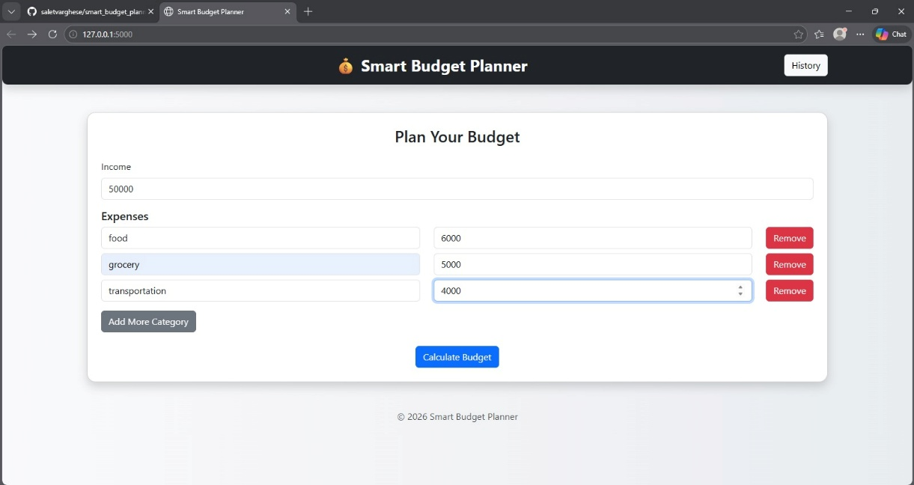
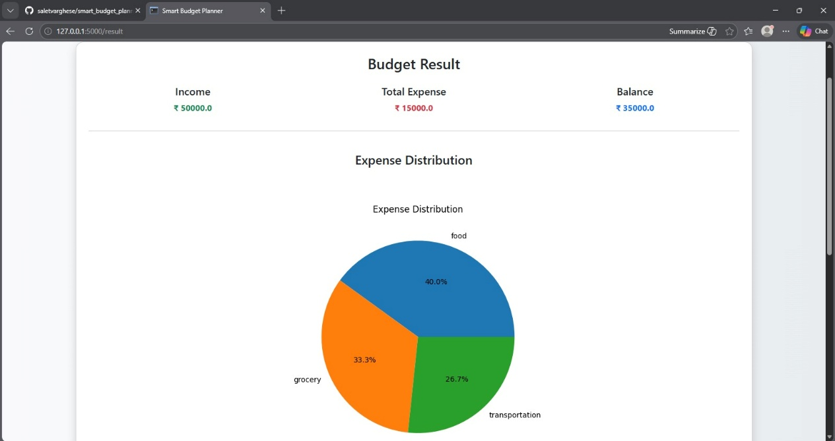
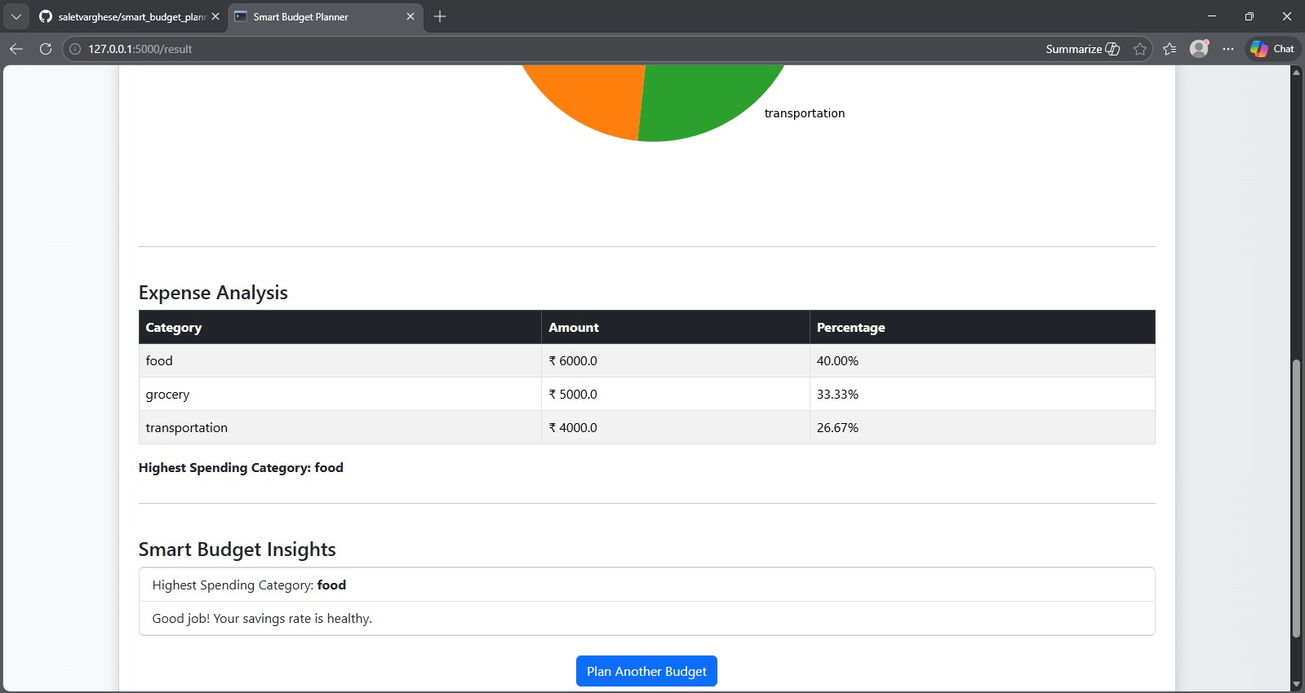
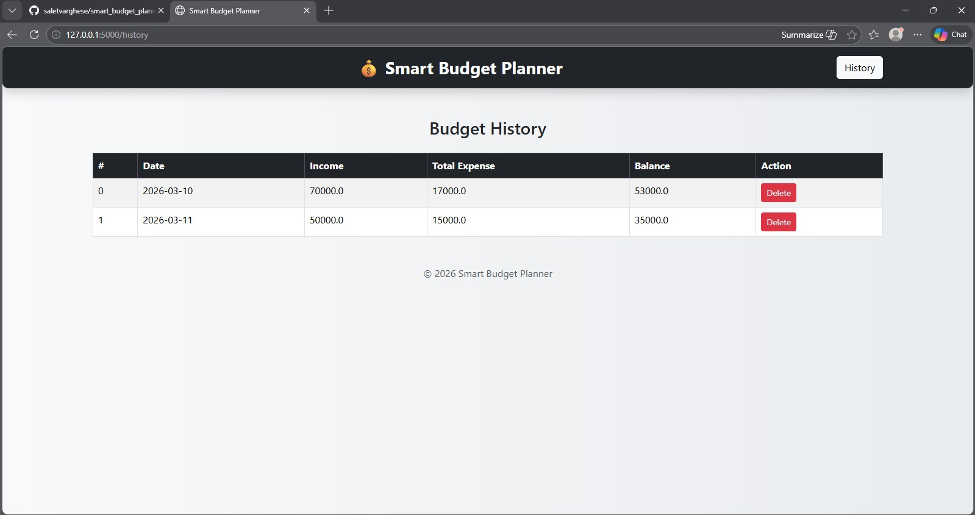

Conclusion & Scope for Mini Project Extension
The Smart Budget Planner is a simple and effective application that helps users track their income and expenses. By providing graphical visualization and smart insights, the system encourages better financial planning. The project demonstrates the practical application of Python libraries for web development, data analysis, and visualization.
In the future, the project can be extended with additional features such as:
- User login and authentication
- Monthly and yearly budget reports
- More advanced financial analysis
- Integration with databases instead of CSV files
- Mobile application version
These improvements could make the system more powerful and suitable for real-world financial management.

References
Python Official Documentation – https://www.python.org
Flask Documentation – https://flask.palletsprojects.com
Pandas Documentation – https://pandas.pydata.org
Matplotlib Documentation – https://matplotlib.org

